Hw 10 Assignment

1. 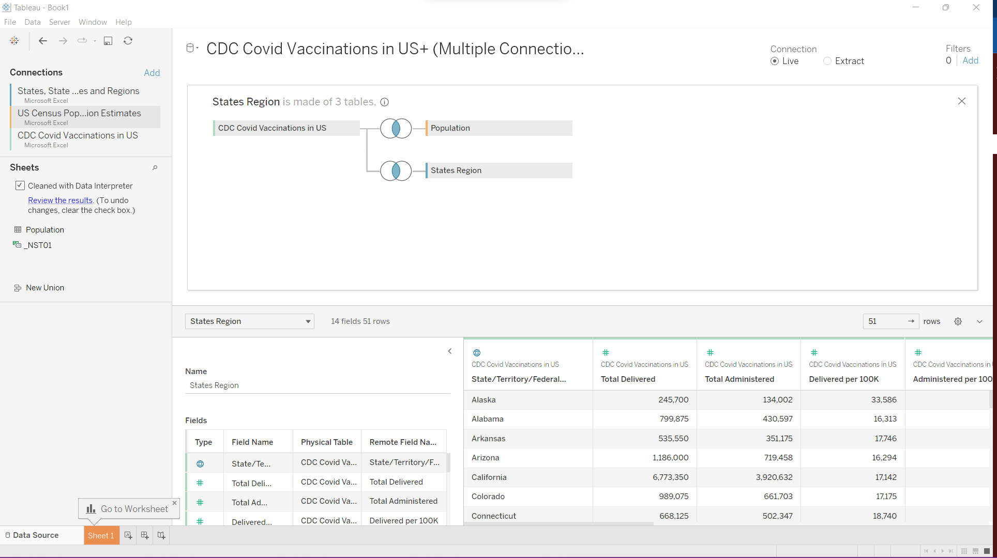
2. Choropleth map that shows the total population by state

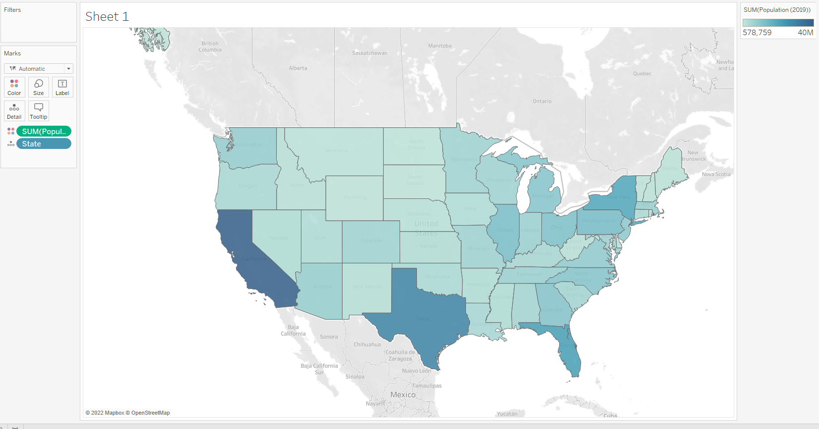

1. Open a new worksheet, create a proportional symbol map that shows the total number of people who have been fully vaccinated (People with 2 doses per 100k) (screenshot)
2. 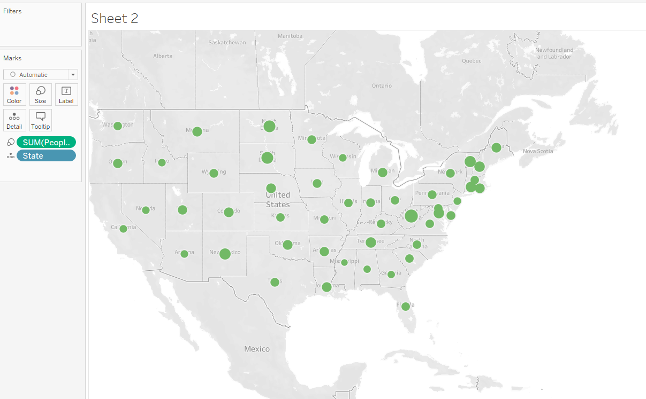

4. Map a copy of your choropleth map (right-click on the tab and choose "duplicate"), create a multi-layer map that combines the choropleth map with the symbol map you created in step 3.